Enough with the 70’s command line technology…
Let’s kick VB into the 21st Century.
First we download Visual Studio 2010 Express (FREE) from:
http://www.microsoft.com/visualstudio/en-us/products/2010-editions/visual-basic-express
Click the “Install Now – English” button.
And let it run.
Go get a cup of coffee, this is gonna take a while.
Back from coffee? Start the install.
Go get another cup of cofee.
And while you’re on that second cup:
Download SP1 at:
http://www.microsoft.com/en-us/download/details.aspx?id=23691
Yup, after it’s done installing, install the service pack.
After you are all installed and patched,
Reboot your system.
Very important!
Always reboot after service packs, uninstalls, or any system modification.
The first program I always assign to new programmers is a simple calculator.
It requires working with objects, variables, and globals.
For the record, this is what we’ll be creating:
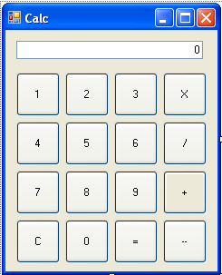
Through the magic of Dot Net,
It’s a self contained EXE.
No fancy installs required.
Want to give it to buddy,
Simply give him the EXE.
How is that possible?
Well, the dot net framework is already installed on most windows boxes.
Many microsoft programs already depend upon it.
So, your exe only contains the different stuff in your application.
Screen layout, flow, and logic.
This links up the Dot Net Runtime installed on the machine.
The same program exe that runs on XP Pro, can run on 2003 Server, Vista, Windows 7, or 2008 Server.
Launching Visual Studio:
Start by launching Visual Studio 2010 Express. You will find in the Start | All Programs | Microsoft Visual Studio 2010 Express folder.
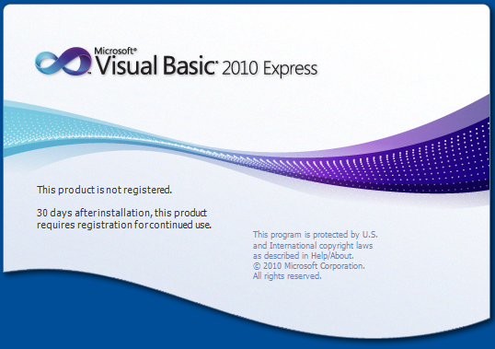
Shortly aftwards you should end up at the home screen:
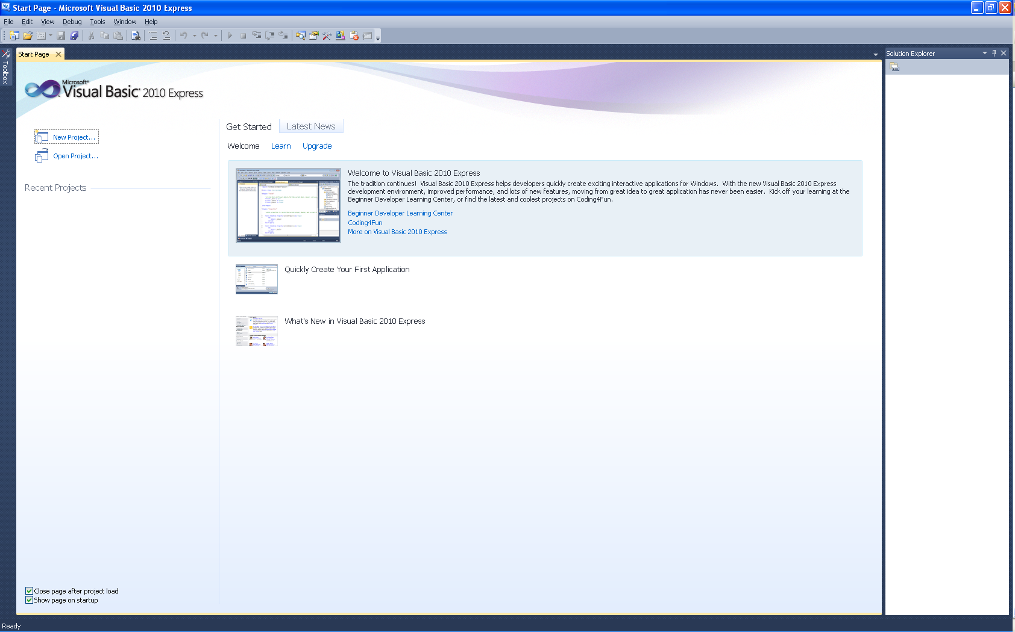
First Time Configuration:
I like to do a little bit of arranging before I begin.
Start by clicking the Toolbox Icon in the upper left.
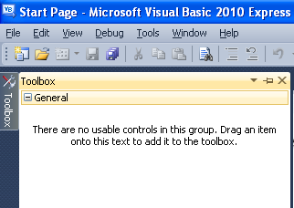
Next we are going to pin it to desktop by clicking the pushpin in the upper right of the window.
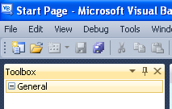
And heres the tricky part, left click and hold at just right of the word Toolbox. Pull your mouse to the right, and the window will undock. Still holding, drag all the way to the right side of the screen. You want to release the left mouse button when the pointer is directly centered in the diamond.
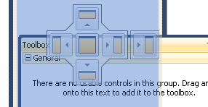
This places both the Solution and Toolbox in the same tool pane. You can switch between tabs in the lower right of the screen. This gives us more room to work with on the screen. We can add more tools to this panel later.
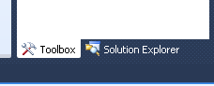

Next, a short talk on C:\Projects. I’ve used a C:\Projects for a very long time. In a single developer windows enviroment the use is not readily apparent. But trust me, a single folder for all your development projects is good idea. Visual basic likes to stick projects under My Documents. As you know, this folder is actually deeply burried on your computer. C:\Projects is easier to find, and easier to type.
In the corparate world, you may be working on a project, and call in sick one day. If your projects folder is under your personal my docs, then other programmers will not be able to access your work. With C:\Projects, any programmer can log in and scan the folder. Trust me, it comes in handy.
So, first things first, create a C:\Projects folder in Windows Explorer. More simply open the Command window, and execute MKDIR \PROJECTS.
Next, we tell visual studio to use that folder, TOOLS | OPTIONS | PROJECTS AND SOLUTIONS | GENERAL. Set Projects Location to C:\PROJECTS.
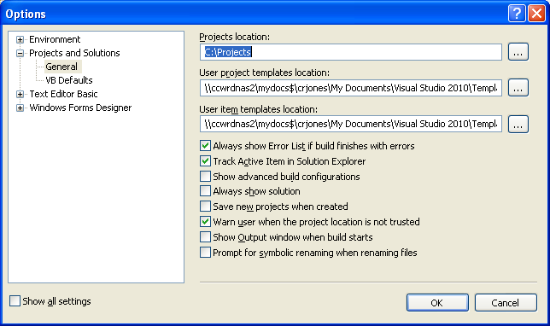
I also like to have line numbers on, so expand Text Editor Basic | Editor. Check Line Numbers.
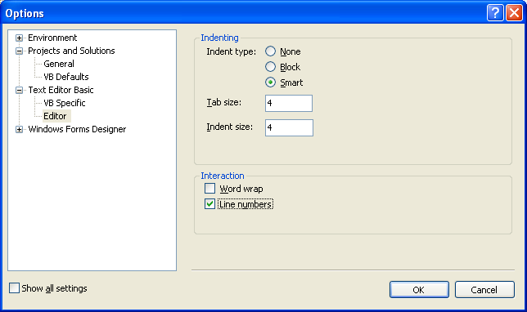
Click OK and you are done with configuration.
Creating the Project:
Now that we have a decent environment, let’s create our first project.
File | New | Project | Visual Basic | Windows Form Application
Set the Name: to Calc
Click OK.
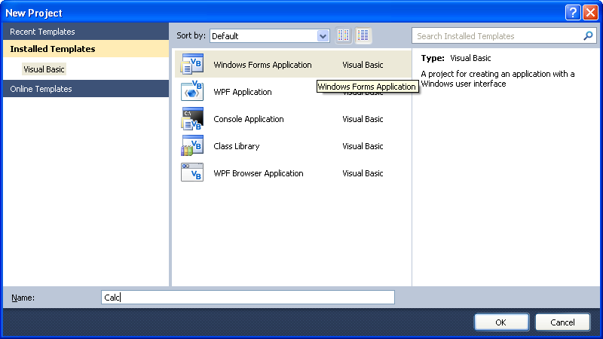
Windows will create the workspace for use, and give us back a blank form.
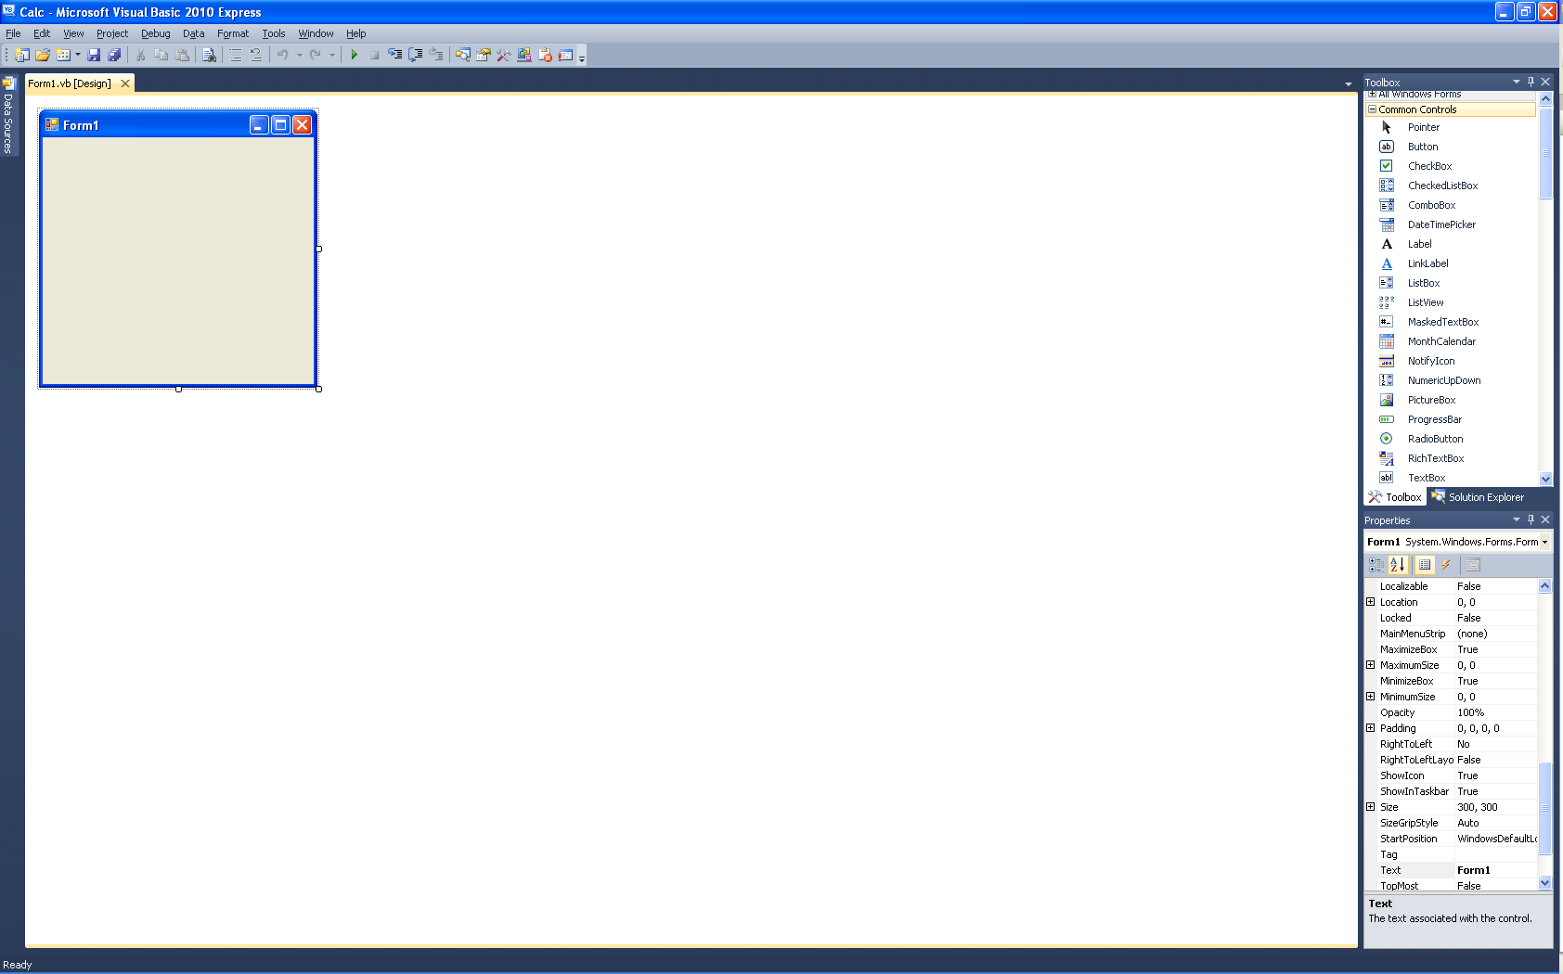
Notice that two new windows have shown up. Datasources to the left and Properties to the bottom right. Again, I like the largest development window possible. Let’s start by dragging the properties window into the toolbox / solution window above, as we did earlier. Expand, pin, and move datasources as before. You can expand the entire area by clicking and dragging on the left boundry. Note that it’s now easier and more compact to swap between solution, toolbox, properties, and datasources. You can rearrange tabs by clicking and dragging. Typically I put solution and toolbox first.
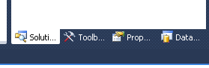
Let’s switch to the toolbox by click the Toobox tab. Locate the button control, left click, hold, and drag it to the upper left of Form1. You should see little alignment guides appear. These appear to help you align objects better and are merely suggestions. In our case, we will take the suggested spacing down and over.
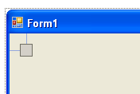
When we release the left mouse button, we magically have Button1 on the screen. Notice the handles around the Button? That indicates it’s the currently selected object. We can view properties of the currently selected object by using the properties tab.
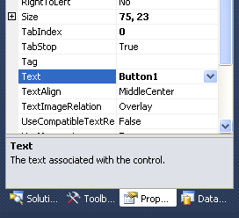
Notice that the Text of this object is Button1. This is the text displayed on the face of the button. If you look back, you’ll see that we wanted this button to display 1. So, let’s overtype the word Button1 with 1. Then click the Tag item. We call that coming-off an input. That’s when the system actually saves the value, and you’ll notice that the button in the form has now changed its face to 1.
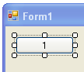 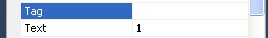
Also notice that we can resize the button by left clicking (and hold) on the lower right handle. Go ahead an resize and notice how the affects the Size property. Well, if resizing the button in the interface sets the property, then setting the property should resize the interface. Let’s set the Size property to 48,48.
Wow, cool, we have a custom, exactly sized button.
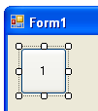
Since we have a great fist button, let’s clone it a few times. Right click on the button in the interface and choose copy. We have to be a little careful here and paste buttons in order to simplify our programming. Left click on the center of Form1. Right Click and select Paste. Drag this new button up to the right of the first button. Do this again, dragging button 3 up to the right of button 2.
Paste again, but drag this one to right below the first button. Continue to paste two more the right of the fourth button.
And paste again below the fourth button, and two more times to the right.
This gives us a bunch of 1 buttons.
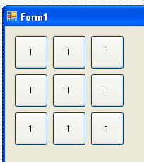
Let’s change the text on the new buttons to a calculator format.
1 2 3
4 5 6
7 8 9
To do this we left click on the button, change the text property, and click out again (tag).
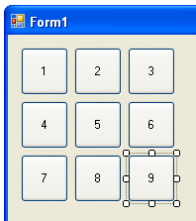
I’d like you to also look at the Name property for each button. Notice that button1 contains a text property of 1, while Button9 has a text property of 9. We use the name property to identify each button through code. VB automatically numbered the buttons Button1-Button9, based on our order of pasting.
A little bit more pasting. Order here is not important. Copy the 1 button as shown.
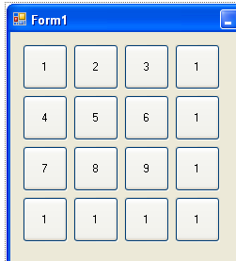
And we are going to set titles and names on these buttons. Let’s start with the button right of 3. That’s name = ButtonMultiply, text = X. Continue down as shown:
ButtonDivide /
ButtonPlus +
ButtonMinus -
Now, going left from minus:
ButtonEquals =
Button0 0
ButtonC C
You should end up with something like this.
Well named buttons Button0-Button9, ButtonMutliply and so on.
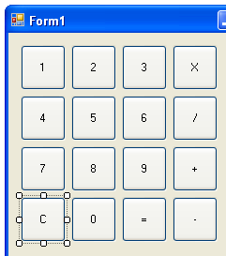
Next, the form name Form1 looks like dumb.
Let’s change that to Calc.
That’s the text property of the form,
So cick on the form and change the Text Property.
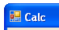
Next we are going to select all the buttons.
Left click and hold to the upper left of button 1 but still inside the form.
Drag the rectangle all the way down to the lower right of the Button minus.
Release and all buttons should be selected.
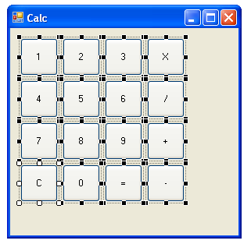
Next we are going to drag all the buttons down, about ½ the height of a button.
Hover over button 3, the cursor should change to cross.
Click and hold, drag downwards.
Left click anyhwere in the form but not on a button to remove the multiple selection.
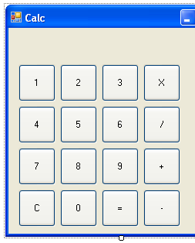
Next, we insert the textbox for the output.
It’s a calculator after all.
Grab a text box from the toolbox.
Drop it above button 1.
Move it to the left to match button 1.
And resize to the right to X.
Like so…
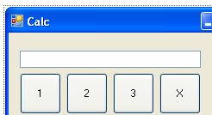
We are also going to change the Name property of the textbox to txtOutput
Select the textbox, change the property.
Set the text property to 0, and the TextAlign property to Right.

Ok, let’s next tighten up the right and bottom margins of the dialog.
Like so…
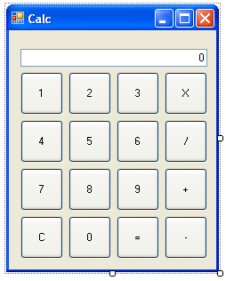
That’s just about it for design.
Just a couple of things to lock the design into place.
Let’s select the form, click on work Calc.
The form has handles around it, as above.
We are going to change the FormBorderStyle
Clicking on Sizable gives us a list of choices.
Choose Fixed Single.
We also really like the form the way it is,
So, let’s change Locked to True.
Now we won’t accidently change anything.
A little lock symbol appears in the upper left of the form.
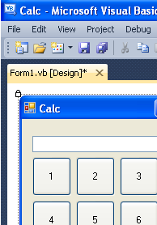
If we ever wanted to change elements on the form again,
We’d need to unlock the form’s locked property first.
Saving our Code:
Notice the * indicated on the current tab, Form1 [Design]* X
This indicates we have unsaved changes.
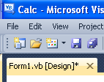
Click the Disk Button immediately above the * to save all changes.
It’s a good idea to save all changes before you do something risky.
Let’s talk about Objects, Properties, and Methods:
We’ve seen a few objects so far… We’ve seen buttons, textboxes, and forms. Properties are variables attached to objects. Each has had the Text property. This allows us to the set the text on the face of the object.
Objects also have Name properties, which is how we refer to objects in code. Each object name must be unique to the form it lives on. Forms within a project, yes, there can be more than one, also must be unique.
In VB6 we used to have Global Variables. In VB.Net we have the concept of an Application Object, with Public Properties. This is the same concept as Global Variables. All Public Properties are available to members of the form or application.
Let’s talk about methods, which we’ll be seeing in the next segment. VB6 had the context of subroutines. Bits of code that can be called from different places in code, in from inside the same subroutine. VB.Net keeps the same concept, but we call them Methods. Remember, the basic object is the Application, and we are probably operating inside of a form within that application. Subroutines defined on the form are called methods. We invoke that method to make the form do something.
All of our custom code will be in various methods of a form.
There is a special kind of method called an Event Handler. These are auto-wired-up to object actions using the Handles keyword. What’s an event action, well anything you can do to an object. Let’s consider a button. It can be clicked. So, one of the first things we are going to do is write a handler for the Button Click event.
Properties, Methods, and Events are where VB.Net quickly departs from other top-down languages. Basically we set up a form, some buttons, and displays, and wait for the user to do something. In our case, we create buttons with numbers and functions, and process bit by bit as users click those buttons. When a user finishes with our program, these will click the X button, sending a Form Close event to our form. Luckily VB.Net takes care of most of the tedious background work for us. We just need to write the interesting bits.
Adding some code:
We’ve got all the interface laid out,
So now its time for some code…
Double click the 1 button.
Visual studio stubs out some code for us automatically.
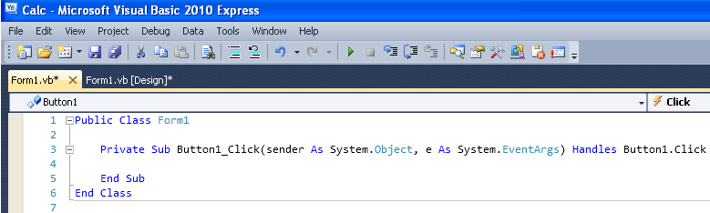
First, we have an object called Form1.
It has a beginning: Public Class Form1,
And an ending: End Class.
Anything between is a part of Form1.
Notice that we have a Private Sub Button1_Click …
Again, and Begin Sub, and End Sub.
Sub is short for subroutine.
But unlike top-down coding,
This is event based coding.
Button1_Click is a subroutine that handles event Button1.Click.
See the Handles Button1.Click.
This event will be fired every time Button1 is clicked.
There are parameters to the subroutine, which we will talk about later.
For now, we’re going to put some code into Button1_Click.
txtOuput.text = val(txtOutput.text & “1”).ToString
Wow, that’s a bit complex.
Ok, step by step.
txtOutput.text =
The text property of the txtOutput object will be set to
txtOutput.text & “1”
Take the text value of txtOutput and add a 1 at the end.
val(txtOutput.text & “1”)
Next we are going to take the value of the above.
That is, convert the string into a number.
val(txtOutput.text & “1”).ToString
Lastly, we are converting the number back to a string.
txtOuput.text = val(txtOutput.text & “1”).ToString
Finally, we stick the value back into txtOutput.
Why?
Well, the default value of the output is 0.
Adding 1 to 0 should be 1, not 01.
Well, now we get to run the program for the first time.
Click the run icon, the green right arrow, >, in the toolbar.
Highlighted here as Start Debugging (F5)
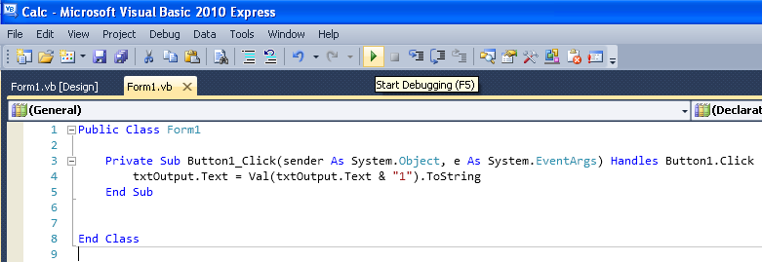
You should have a running program.
Click the 1 a couple of times,
You should see 0.
Then 1.
Then 11.
Then 111.
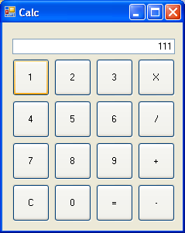
Click 2 and notice that nothing happens.
Click the X to terminate the program.
Let’s code the 2 button to do something.
Copy the code for button1,
And paste it below the End Sub.
Adjust the code by changing references of 1 to 2.
You should have:
Private Sub Button2_Click(sender As System.Object, e As System.EventArgs) Handles Button2.Click
txtOutput.Text = Val(txtOutput.Text & "2").ToString
End Sub

Run the code again,
and notice that 1 and 2 both work.
While we could code and handler for each button,
There would be a lot of replicated code.
Luckily, VB.net can use one handler for many objects.
First, we change the handler as follows:
Please notice this is one continuous line breaking into 2 due to Word limitations.
Private Sub Button1_Click(sender As System.Object, e As System.EventArgs) Handles Button1.Click, Button2.Click

You can also delete the handler for Button2.
If we were to run the code now,
Button1 and Button2 would both work,
But always result add a 1 to output.
That’s just not right.
What we need to do is differentiate between calls for button1 and button2.
And that’s where parameters to handlers come in.
Remember we skipped the discussion of sender and e earlier?
Well, sender is the object that send the click message to this handler.
It is a generic type “object.”
What we’d like to do is read the text face of the button,
And add that to the output.
Fortunately, this is pretty simple with the sender object.
As the sender is a generic object,
We have to first change its type to a button.
In some languages, like C, this is called casting.
There is a function in vb for doing this, ctype().
ctype(sender,button) will do the job for us.
Convert sender to a type button.
To get at the face of button, we use the text property.
ctype(sender,button).text
In our current code, we want to replace “1” with the value of the button clicked.
txtOutput.Text = Val(txtOutput.Text & "1").ToString
That’s a simple modification:
txtOutput.Text = Val(txtOutput.Text & ctype(sender,button).text).ToString
Try to run the code again.
Notice that buttons 1 and 2 now operate.
Close the window,
And add handlers for buttons3 – button 9, and button0.
Private Sub Button1_Click(sender As System.Object, e As System.EventArgs) Handles Button1.Click, Button2.Click, Button3.Click, Button4.Click, Button5.Click, Button6.Click, Button7.Click, Button8.Click, Button9.Click, Button0.Click
txtOutput.Text = Val(txtOutput.Text & CType(sender, Button).Text).ToString
End Sub
Run the code again.
Observe that all the numeric buttons now work.
Close the debugged program.
It’s time to start working on function keys.
Let’s start with the easiest: C.
The C key should clear the display.
In our program, that’s as easy as setting the output to “O”.
txtOutput.text = “0”
We could create a new handler to do this.
But it might be simpler to use the same handler as the buttons.
My changes are in red.
Private Sub Button1_Click(sender As System.Object, e As System.EventArgs) Handles Button1.Click, Button2.Click, Button3.Click, Button4.Click, Button5.Click, Button6.Click, Button7.Click, Button8.Click, Button9.Click, Button0.Click, ButtonC.Click
Dim sButton as String = Ctype(Sender,Button).Text
txtOutput.Text = Val(txtOutput.Text & sButton).ToString
End Sub

So, we started by using the same handler.
We create a new String sButton, and set it to the incoming text.
Then we just append that text as before.
We can’t really run this code yet,
Because 0C would not convert to a good number,
And would break our program.
What we need to do is intercept the C before it’s processed by txtOutput.
Concentrating on our code now, I insert the following:
Dim sButton as String = Ctype(Sender,Button).Text
if sButton = "C" Then
txtOutput.text = "0"
return
end if
txtOutput.Text = Val(txtOutput.Text & sButton).ToString
The if command does some conditional processing.
We are checking the sButton for C, if it is then we do the following:
Set the txtOutput to 0, and Return.
Return means, exit the subroutine right here.
Do nothing else.
Try the new code,
You will see that buttons 0-9 and C button now work.
The rest of the buttons are going to take some thought.
X, /, +, - are going to need two things to operate on.
Typically with any of the above keys we store the current output in memory.
Then wait for another operation or = to perform the operation.
Obviously we also have to remember what function we were doing.
We are going to add two properties to the class.
Public sOperation as String = “”
Public dValue as Double

This new code goes directly above the handler.
All together it should look like this (pardon the line wraps)
Public Class Form1

Public sOperation As String = ""
Public dValue As Double

Private Sub Button1_Click(sender As System.Object, e As System.EventArgs) Handles Button1.Click, Button2.Click, Button3.Click, Button4.Click, Button5.Click, Button6.Click, Button7.Click, Button8.Click, Button9.Click, Button0.Click, ButtonC.Click, ButtonMultiply.Click, ButtonDivide.Click, ButtonPlus.Click, ButtonMinus.Click, ButtonEquals.Click
Dim sButton As String = CType(sender, Button).Text
txtOutput.Text = Val(txtOutput.Text & sButton).ToString
End Sub
End Class

Always a good idea to save and run code after modification.
Go ahead and run. Notice that code still runs.
Next, we need some fairly complex logic to make our calculator work.
And with this, we’ll introduce a new construct, the Select Case.
Private Sub DoOperation(NewOp As String)
Dim i As Double = Val(txtOutput.Text)
Select Case NewOp
Case "C"
dValue = 0
sOperation = ""
Case "="
Select Case sOperation
Case "" : Return
Case "X" : dValue *= i
Case "/" : dValue /= i
Case "+" : dValue += i
Case "-" : dValue -= i
End Select
sOperation = ""
Case Else
dValue = i
sOperation = NewOp
txtOutput.Text = "0"
Return
End Select
txtOutput.Text = dValue.ToString("0")
End Sub
Taking the new code apart, we start with:
Private Sub DoOperation(NewOp As String)
Well, this is simply a subroutine that takes a string as an input.
In our case, it’s taking the key that was pressed.
Hopefully one of C, = , X, /, +, or -.
We name that new string NewOp, for NewOperation.
Next, for simplicity, we conver the txtOuptut.Text into a decimal value,
And store this value in i.
We can consider that i is a temporary value, and we don’t care much abou its name.
Dim i As Double = Val(txtOutput.Text)
Now begins the Switch Case statement:
Select Case NewOp
Every switch could be written as a series of If ElseIf Else’s.
It’s just more compact and easier to read.
In our case we’ll be switching on the value of NewOpt,
That is, the button that was passed into this routine.
So, the first case is now stated:
Case "C"
Basically, this is the “If Newop =” part of the statement.
If NewOp = “C” then do the following statements.
The statement block end at the next Case, Else, or End Case statement.
That saves us from a bit of repetive typing.

Cases also have one great feature.
Only the first case that matches is processed.
Any further cases are disregarded up the line following End Case.
So, let’s look specifically at this Case “C” block.
I’ve eliminated any other extraneous code:
Private Sub DoOperation(NewOp As String)
Dim i As Double = Val(txtOutput.Text)
Select Case NewOp
Case "C"
dValue = 0
sOperation = ""
End Select
txtOutput.Text = dValue.ToString("0")
End Sub
As we discussed, Private Sub stores the current button in the NewOp string.
i is set to the numberic value of the text input.
And we fall into a NewOp = “C” block:
dValue = 0
sOperation = ""

Remember we created the global properties dValue and sOperation earlier.
Look back at the code and note that 0 and “” were the defaults for these properties.
Here, if the user presses “C”, we reset to defaults, fall out of the Case, and drop to the line:
txtOutput.Text = dValue.ToString("0")
If you look up ToString() in Online Help, you’ll notice that it can take a string parameter. This method is able to format and object according to a parameter. In this case “0” will format the number as 0, or any other number, no decimal places. In contrast “#” format would have suppresed a 0 ouput, instead returning a blank. You can read more about the ToString() method in online help.
Notice that we assign txtOutput to the ToString(“0”) of dValue. That’s a simple way of updating the text box to the formatted result of a value.
In our case, dValue is now 0, so txtOutput should be formatted to 0.
But what is sOperation? We’ll, that the Stored Operation, or the action we would be perorming when = is hit. In our scenario, we will enter a number, hit a function, enter another number, then hit =. sOperation will store that function key until we need it when = is pressed.

It’s quite useful to imaging the input at a certain value, and follow the code logic.
What’s with this fancy indenting anyhow? We use indenting to indentify embedded levels of logic. In this bit of code, we have a Case Statement within a Case Statement. We’ll come back to this in a bit when we look at the logic for Case “=”.
He’re I’m trimming down the logic to the relevent portion. Notice how indenting makes it easy to find the “C”, “E”, and Else blocks.
Select Case NewOp
Dim i As Double = Val(txtOutput.Text)
Select Case NewOp
Case "C"
Case "="
Case Else
dValue = i
sOperation = NewOp
txtOutput.Text = "0"
Return
End Select
For now, we’re going to look at Case Else. Case Else is tripped if nothing else in the case statement is matched. In our case, that occurs if NewOp is neither “C” or “=”. Basically any entry of X, /, +, or -.
So, at this point, let’s imagine we’ve entered a number, 50, and hit the X key:
First I would contain the value 50, due the statement:
Dim i As Double = Val(txtOutput.Text)
We would fall through to the Case Else block since New Op is neither “C” or “=”.
Select Case NewOp
Case "C"
Case "="
Case Else

Then we store i, 50, to dValue. dValue holds the first value entered while we enter the second number.
dValue = i

Next, we memorize the New Op, X, for later use. (When we hit the “=”.)
sOperation = NewOp
Do you remember dValue and sOperation? We defined those as globals earlier. So they will hang around between button presses. i will be forgotten and recreated, any time we push a function key.

Next, we set the txtOutput to “0”. That’s a good default and starting point the for second number entry.
Lastly, we Return. That’s another command that simply tells our subroutine to end processing here and return.

So simply:
memorize first value
memorize the function
set the display to “0”
and exit

All we need to do now is discuss the “=” case.
Private Sub DoOperation(NewOp As String)
Dim i As Double = Val(txtOutput.Text)
Select Case NewOp
Case "C"
Case "="
Select Case sOperation
Case "" : Return
Case "X" : dValue *= i
Case "/" : dValue /= i
Case "+" : dValue += i
Case "-" : dValue -= i
End Select
sOperation = ""
Case Else
End Select
txtOutput.Text = dValue.ToString("0")
End Sub
When “=” is detected, we are going to switch on the memorized operation.
Case "" : Return
If the last operation was nothing, then we simply return and do nothing. 50 = should display 50.
Case "X" : dValue *= i
If the last operation was X, then we peform the multipication. The stored value is equal to itself times i. Simple and clean. This statement is equivelent to dValue = dValue * i, it’s just more compact and easier to read.
Case "/" : dValue /= i
Case "+" : dValue += i
Case "-" : dValue -= i
We preform the rest of the operations as required.

End Select
sOperation = ""
When we fall through and out of the inner case, we set the memorized operation to nothing. Simply we did the operation, and don’t need it anymore.

Case Else
End Select
txtOutput.Text = dValue.ToString("0")
Lastly, we fall through the outer case, and set the txtOutput to the value of the stored value. In this case, that’s the result of the requested operation.
And that’s the end of our complext logic. We’ve handled button presses for C, =, X, /, +, and -. Insert the code, just after the End Sub of the handler. Code should now look like:
Public Class Form1

Public sOperation As String = ""
Public dValue As Double

Private Sub Button1_Click(sender As System.Object, e As System.EventArgs) Handles _
Button1.Click, Button2.Click, Button3.Click, Button4.Click, Button5.Click, _
Button6.Click, Button7.Click, Button8.Click, Button9.Click, Button0.Click, _
ButtonC.Click, ButtonMultiply.Click, ButtonDivide.Click, ButtonPlus.Click, _
ButtonMinus.Click, ButtonEquals.Click
txtOutput.Text = Val(txtOutput.Text & CType(sender, Button).Text).ToString
End Sub

Private Sub DoOperation(NewOp As String)
Dim i As Double = Val(txtOutput.Text)
Select Case NewOp
Case "C"
dValue = 0
sOperation = ""
Case "="
Select Case sOperation
Case "" : Return
Case "X" : dValue *= i
Case "/" : dValue /= i
Case "+" : dValue += i
Case "-" : dValue -= i
End Select
sOperation = ""
Case Else
dValue = i
sOperation = NewOp
txtOutput.Text = "0"
Return
End Select
txtOutput.Text = dValue.ToString("0")
End Sub

End Class

Hmmm, what’s up with this underbar _ thing. _ is simply placed at the end of a line to indicate that it continues on the next line. Allows us to pretty up our printouts to fit on a page without line wrapping.
If we run the code, nothing happens when we push 50 X. Why?
Well, most simply, we haven’t called our new logic DoOperation yet.
Notice that you have stop the code running before you can make any changes.
Private Sub Button1_Click(sender As System.Object, e As System.EventArgs) Handles _
Button1.Click, Button2.Click, Button3.Click, Button4.Click, Button5.Click, _
Button6.Click, Button7.Click, Button8.Click, Button9.Click, Button0.Click, _
ButtonC.Click, ButtonMultiply.Click, ButtonDivide.Click, ButtonPlus.Click, _
ButtonMinus.Click, ButtonEquals.Click
txtOutput.Text = Val(txtOutput.Text & CType(sender, Button).Text).ToString
End Sub
Let’s look more specifically at the button hander.

txtOutput.Text = Val(txtOutput.Text & CType(sender, Button).Text).ToString
We get the Button from the text and append it to the output window, with a little numeric and string manipulation along the way. What we really need to do is get the button text, look at, decide if we need to use our new logic, and the display the output.

Dim b as String = CType(sender, Button).Text
txtOutput.Text = Val(txtOutput.Text & b).ToString
Here we have simply broken the statement into 2 lines. The end result is the same.
We could code some new logic to check for the state of each possible string and call the new logic.
If b=”C” or b=”=” or b=”X” or b=”/” or b=”+” or b=”-1” Then
DoOperation(b)
Return
End if
If b is any one of the values, the operation. Since operation does the display stuff, we don’t need to do anything else, and just stop here.
Of course, we remember that DotNet is an object oriented language. There’s always an easier way. If you look at strings, you will notice that they have a lot of cool methods. .Length, .Substring, .Contains and many more. We are intersted in the .Contains method. We could easily construct a string on the fly, with “C=X/+-“. What’s not readily apparent is that you can immediately operate on methods of that new string:
“C=X/+-“.Contains(b)
That asks if the button text, b, is contained in the string. We get a yes or no answer back, which is perfect for and if statement:

If “C=X/+-“.Contains(b) Then
DoOperation(b)
Return
Endif

Let’s put that into final code:
Private Sub Button1_Click(sender As System.Object, e As System.EventArgs) Handles _
Button1.Click, Button2.Click, Button3.Click, Button4.Click, Button5.Click, _
Button6.Click, Button7.Click, Button8.Click, Button9.Click, Button0.Click, _
ButtonC.Click, ButtonMultiply.Click, ButtonDivide.Click, ButtonPlus.Click, _
ButtonMinus.Click, ButtonEquals.Click
Dim b as String = CType(sender, Button).Text
If “C=X/+-“.Contains(b) Then
DoOperation(b)
Return
Endif
txtOutput.Text = Val(txtOutput.Text & b).ToString
End Sub
Go ahead and run the code again. 50 x 2 =, 100, wow, it works! But remember dValue continues to contain the value of the previous operation? Try / 4 =, 25! Wow, like a real calculator!
I’m going to make one last change to the code based on a coding style in basic. The full colon : can be used to combine different statements on a single line. This is most useful if you want to create compact code, expecially for if statements that just do one thing. I call these compressed if statements, and this one might be easier to read as:
That’s a bit cleaner, and reduces the core logic of the button handler to:
Dim b as String = CType(sender, Button).Text
If “C=X/+-“.Contains(b) Then : DoOperation(b) : Return : Endif
txtOutput.Text = Val(txtOutput.Text & b).ToString
Save your project once again.
Distributing my EXE:
This is all well and good, but now I’d like to give a copy of my masterpiece to a friend. Let’s go looking for that exe file I spoke about earlier.
We know that we saved our project in C:\Projects\Calc. If we look at that folder, we’re going to see a bunch of files. A lot of these folders were created by visual studio as scratch files when compiling the application. Obj are object files, and the term goes back to the mainframe days. Source code compiles to object files, object files are linked into an exe. We can safely ignore the Calc\/Obj folder.
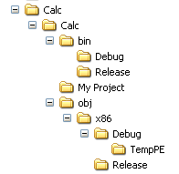
We are initesting in the bin folder, this is where DotNet stores the EXE, and related files. Currently we are working in Debug mode, so our EXE will be in the Debug folder. Release mode produces code without debugging information, the code is cleaner and runs faster, but much less developer friendly. Navigate to C:\Projects\Calc\Bin\Debug

Calc.exe
Calc.pdb
Calc.vshost.exe
Calc.vshost.exe.manifest
Calc.xml
Woah, that’s a lot more than a simple exe. The good news is that our full EXE is contained in one file, Calc.EXE, and it can stand alone without any of the supporting files. The other files are used by visual studio to track execution of the program and provide feedback if an error is encountered.

Right Click and Copy the Calc.EXE program. Navigate to your desktop and drop it there.
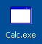

Double click the Calc.EXE icon. You’re calculator is running, and can be copied to any program that runs the current Microsoft Framework. In fact, protections built into the program will trigger if the user does not have Dot Net installed, and tell them how to install it!
Congratulations, you’ve created your firt running Windows App, start to finish.

Next Steps:
One of the most important things in any application development is testing. Try to get a small group of people to test your application before distributing to a very large amount of people. Better to embarras yourself in front of your friends, than the world.
Let’s test the bane of all calculators, division by 0:
25 / 0 =
Infinity?
Yes, 25/0 is undefined.
At least it didn’t crash.
As homework, you might like to set the output to 0 if division by 0 is detected.
This is the typical operation of most modern calculators.
Let’s try typing into the output window.
Click in the window and type CALC
Hmmm, that’s not relaly right.
We shouldn’t be able to type into this window.
Fortunately there is a ReadOnly property which can be set to True on txtOutput.
Remember that you must first unlock the form to make changes.
Don’t forget to relock when done.
What do all these changes do to our EXE that we copied ealier.
Try running the Calc.EXE on the desktop again.
Are our changes included?
Why or why not?
How would we fix this?

